***Step 1. Checking the protection of reading / writing pages of the FLASH memory of the microcontroller.***

The ST-LINK Utility is used for verification. Connect to microcontroller: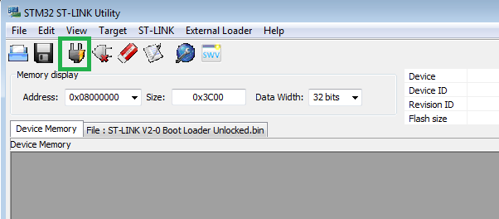

Then, either through the key combination Ctrl + B, go to the Option Bytes section, or through the program menu.

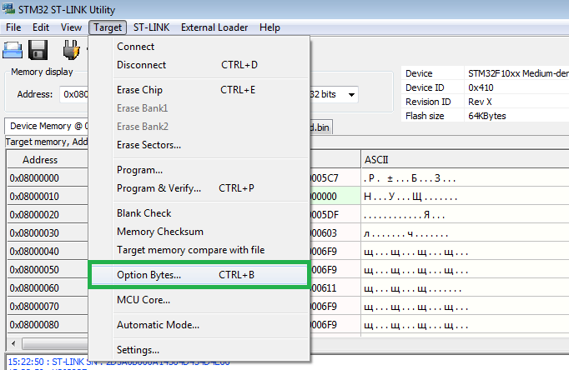

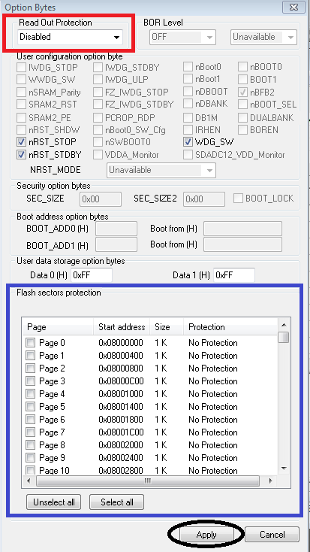

The Read Out Protection item (highlighted with a red rectangle in the figure above) allows you to enable or disable the write / read protection of the FLASH memory of the microcontroller. If Enabled is set, then there is protection! To be able to write and read the memory of the microcontroller, set this item to Disabled.

You can leave the rest of the options as shown in the figure above. To apply all the changes, click on the "Apply" button (highlighted in the figure with a black oval).

***Step 2. Loading a binary (binary) file into the FLASH memory of the microcontroller.***

To determine the correspondence between the phases and the hall sensors on your motor, you must use the test code from the "test" folder. In total there are 6 binary files in the folder. The motor will rotate in 2 out of 6 cases in a different direction.

The algorithm of actions is as follows:

1. Load the “test1” code into the microcontroller.

2. Please set the voltage to 12V and current limit to 1A on the laboratory power supply. Connect power from the laboratory unit to the board.

3. If the motor does not start to rotate, the current is high and makes sounds, then turn it off immediately. The code is not suitable, you need to download the following code "test2".

4. Proceed in the same way until you select the test code you need, and the engine starts to rotate in the right direction

After selecting the test code, load the working code into the microcontroller from the “work” folder with the corresponding number. For example, the code "test3" rotates the motor in the right direction, then use the code "work3" to control the motor.

Open the binary file using the "Binary File" button.

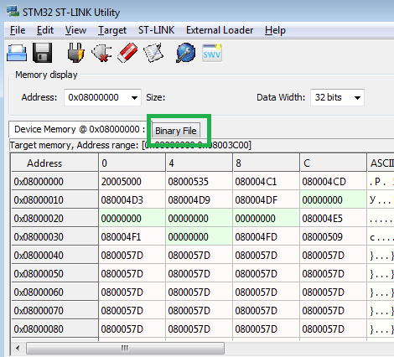

Either through the top menu items Target -> Program… or Target -> Program & Verify… (the only difference between the items is that the downloaded binary file is checked for compliance with the source file that is in the computer's memory).

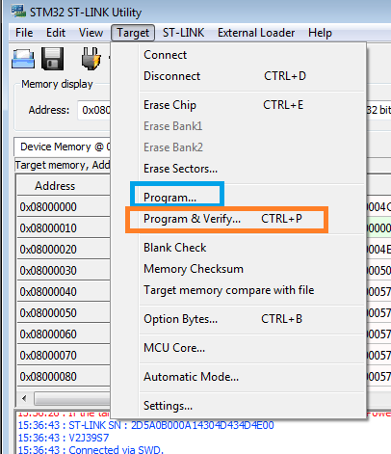

Then, in the explorer window that opens, go to the folder with the source code and the project for the microcontroller, for example, the project is called "BLDC". Then the binary file will be located at the following path: "...\Debug\BLDC.bin".

After selecting the file through "Binary File" it is necessary to select one of the programming options through the Target menu. Next, a window will appear where you click on "Start".

After successfully downloading the program, disconnect from the microcontroller by pressing the button shown below.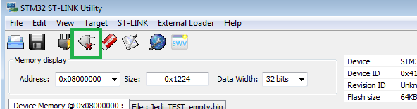

**Note:** the button to the right  allows you to clear the memory of the microcontroller. When you press this button, ST-LINK Utility will ask for confirmation. Click "OK", after which the memory of the microcontroller will be cleared.